NON-DISCLOSURE AGREEMENT
This Agreement, dated as of the last date set forth below, is made by and entered into by and between TriMech Solutions, LLC, a Delaware limited liability company, and its subsidiaries, with its principal office at 4991 Lake Brook Drive, Suite 300, Glen Allen, VA, 23060 and Brag & Bev L.L.C ,
located at 105 Pendleton Trail, Tyrone, GA 30290 . The parties hereby agree as follows:

DEFINITIONS

  - "Confidential Information" means any information of the Disclosing Party, whether of a technical, business or other nature (including, without limitation, information relating to the Disclosing Party's technology, software, products, services, designs, methodologies, business plans, finances, marketing plans, customers, prospects, or other business affairs), that is disclosed by the Disclosing Party (in writing, verbally or otherwise) to the Receiving Party during the Term.
Confidential Information does not include any information that: (a) was acquired by the Receiving Party prior to the beginning of the Term without any restriction as to use or disclosure; (b) is independently acquired by the Receiving Party after the beginning of the Term without any restriction as to use or disclosure and without any reliance upon or use of any of the Disclosing Party's Confidential Information; or (c) is or becomes part of the public domain through no fault of the Receiving Party.
  - "Confidential Materials” means any document, CD, DVD, external mass storage device, tape, writing, copy of computer screen, or other tangible item that contains any Confidential Information, whether in printed, handwritten, coded, magnetic, or other form and whether delivered by the Disclosing Party or made by the Receiving Party. Confidential Materials include intellectual property.

  - "Disclosing Party" means a party that discloses any of its Confidential Information to the other party under this Agreement.

  - "Receiving Party" means a party that receives any Confidential Information from the other party under this Agreement.
  - "Term" means three (3) years from the date of final signature on this Agreement.

OBLIGATIONS

  - Subject to the terms of this Agreement, the Receiving Party shall not, without the prior written consent of the Disclosing Party, disclose the Confidential Information to any third party. If the Receiving Party obtains the prior written consent of the Disclosing Party and thereafter discloses Confidential Information or Confidential Materials to a third-party contractor, the Receiving Party shall ensure that the contractor shall be bound by the same requirements agreed to in this Non-Disclosure Agreement. The Receiving Party shall be liable for any breach of this Agreement by such contractor. Without limitation of the foregoing, the Receiving Party agrees not to use any Confidential Information or Confidential Materials of the Disclosing Party except as specifically required to explore business opportunities whereby one of the parties to this Agreement may supply the other party with products or services
(“Purpose”).

  - The Receiving Party will protect any Confidential Information and Confidential Materials of the Disclosing Party from any unauthorized use, disclosure, copying, dissemination, or distribution. Without limitation of the foregoing, the Receiving Party will: (a) make such Confidential Information and Confidential Materials available only to those of its employees, agents, and other representatives who have a need to know for the Purpose specified in Section B.1. above, and who have agreed or are otherwise obligated to comply with this agreement; it being understood that the Receiving Party shall be liable for any breach of this Agreement by its employees, agents and representatives; (b) not disclose or make available such Confidential Information or Confidential Materials to any unauthorized third party; (c) not reverse engineer, decompile, or disassemble any Confidential Information and Confidential Materials; and (d) protect the confidentiality of the Confidential Information with at least the same degree of care with which it protects its own confidential information, by means of technological and procedural safeguards that are suitable to the nature and sensitivity of the information and that meet or exceed industry standards.

  - Notwithstanding the preceding paragraph, the Receiving Party may disclose or produce any Confidential Information or Confidential Materials of the Disclosing Party if and to the extent required by any court order or governmental action, provided that the Receiving Party gives reasonable advance notice of the same to the Disclosing Party as to afford the Disclosing Party a reasonable opportunity to appear, object, and obtain a protective order or other appropriate relief regarding such disclosure.
  - All Confidential Information and Confidential Materials remain the property of the Disclosing Party. This Agreement may not be interpreted or construed as granting any license or other right under any patent, copyright, trademark, trade secret, or other proprietary right. T h e D i s c l o s i n g P a r t y m a k e s n o r e p r e s e n t a t i o n o r w a r r a n t y r e g a r d i n g t h e a c c u r a c y o r c o m p l e t e n e s s o f t h e C o n f i d e n t i a l I n f o r m a t i o n . The Receiving Party will promptly destroy or return Confidential Information and Confidential Materials to the Disclosing Party upon request or when they are no longer needed for the Purpose described in Section B.1, whichever occurs earlier.

MISCELLANEOUS

  - The parties' respective obligations under this Agreement with respect to Confidential Information and Confidential Materials that are disclosed during the Term will survive any termination or expiration of this Agreement.
  - In the event of any breach of this Agreement, the Disclosing Party may suffer irreparable harm and have no adequate remedy at law. In such event, or the threat of any such event, the Disclosing Party will be entitled, in addition to any and all other remedies, to injunctive relief, specific performance, and other equitable remedies without proof of monetary damages or the inadequacy of other remedies.

  - This Agreement will be interpreted and enforced in accordance with the laws of the Commonwealth of Virginia. Each party hereby consents to the jurisdiction and venue of any state or federal court located in Virginia, with regard to any legal action relating to this Agreement.

  - This Agreement contains the entire agreement and understanding of the parties relating to the subject matter hereof, and supersedes any and all prior discussions, understandings, and agreements between the parties. No amendment or modification of any provision of this Agreement shall be effective unless in writing and signed by authorized representatives of each party.

IN WITNESS WHEREOF, the parties have, by their authorized representatives, executed this Agreement as of the date set forth below.

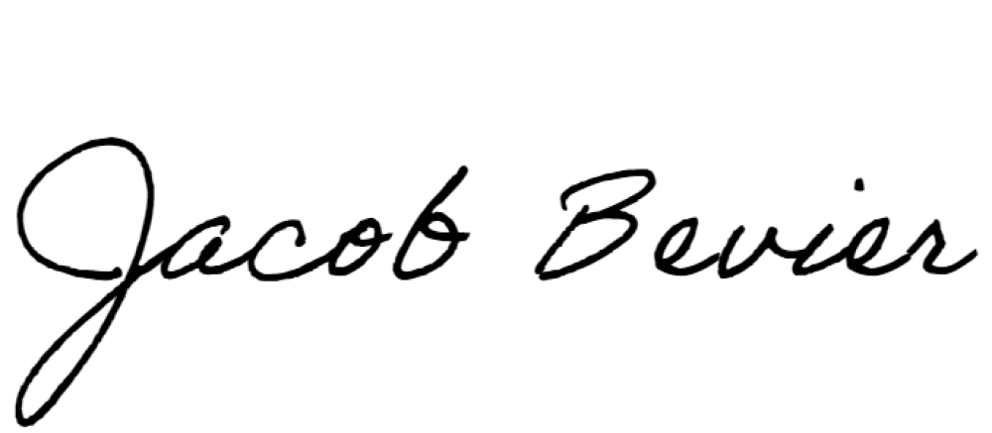
TriMech Solutions, LLC
Company
Signature
Company

Signature

Jacob Bevier
Printed Name Printed Name
CEO
Title Title
24 January 2025
Date Date

